**DAILY ONLINE ACTIVITIES SUMMARY**

|  |  |  |  |  |  |  |  |  |
| --- | --- | --- | --- | --- | --- | --- | --- | --- |
| **Date:** | **30/05/202** | | | | | **Name:** | **Anjali Manohar Prabhu** | |
| **Sem & Sec** | **4th Sem Section - ‘A’** | | | | | **USN:** | **4AL18CS007** | |
| **Online Test Summary** | | | | | | | | |
| **Subject** | | **1.Data Communication**  **2. Complex analysis, probability and statistical methods** | | | | | | |
| **Max. Marks** | | **30**  **30** | | **Score** | | | **27**  **NA** | |
| **Certification Course Summary** | | | | | | | | |
| **Course** | **Vector Lab Exercise** | | | | | | | |
| **Certificate Provider** | | | 1. **Great Learning Academy** | | **Duration** | | | **2.5hrs** |
| **Coding Challenges** | | | | | | | | |
| **Problem Statement: Write a c program to count Uppercase, Lowercase, special character**  **And numeric values for a given string** | | | | | | | | |
| **Status: Completed** | | | | | | | | |
| **Uploaded the report in Github** | | | | | **YES** | | | |
| **If yes Repository name** | | | | | [**https://github.com/vinisharen/lockdown-coding**](https://github.com/vinisharen/lockdown-coding) | | | |
| **Uploaded the report in slack** | | | | | **NO** | | | |

Online Test Details: DC online test was conducted from 9:15 am to 9:55 am. The portion for the IA was 3rd module and the 4TH module there were 30 questions and the time limit was 45 minutes the question were MCQ type and each question consist of 1 mark

SNAPSHOT: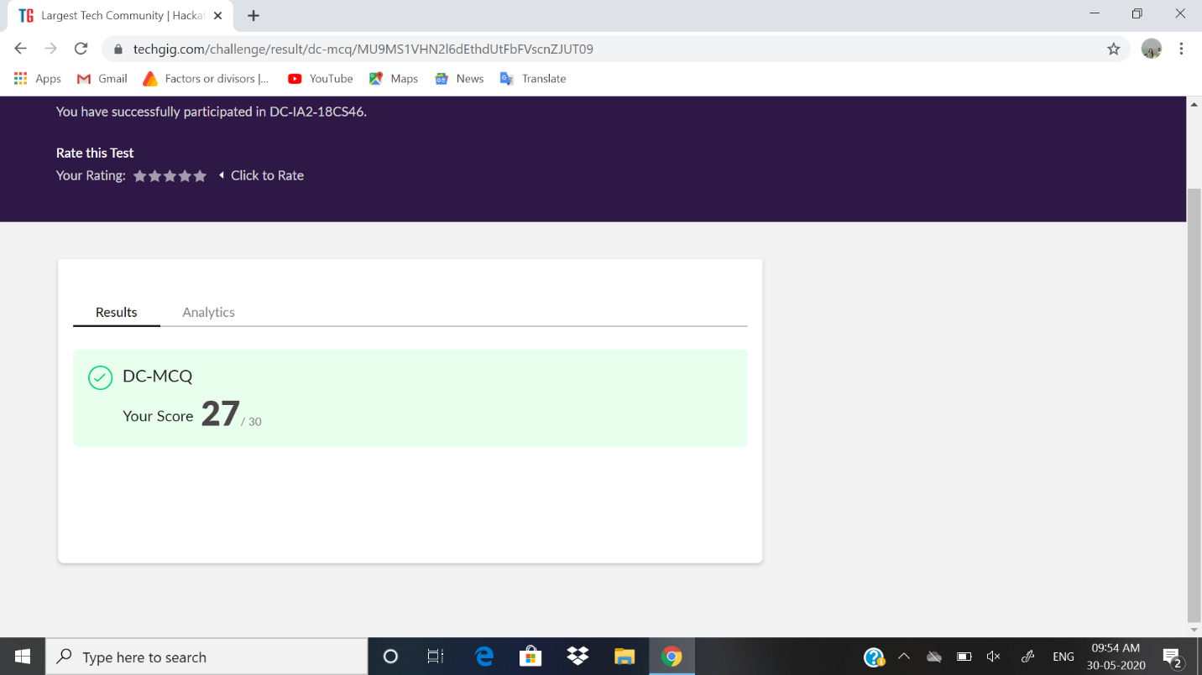

Math test was scheduled from 3:00 pm to 3:40 pm. The portion for the IA was module 3 there were 30 question and the time assigned was 40 minutes the question were MCQ type

Certification Course Details: For a lot of higher level courses in Machine Learning and Data Science, you find you need to freshen up on the basics in mathematics - stuff you may have studied before in school or university, but which was taught in another context, or not very intuitively, such that you struggle to relate it to how it’s used in Computer Science. This specialization aims to bridge that gap, getting you up to speed in the underlying mathematics, building an intuitive understanding, and relating it to Machine Learning and Data Science.

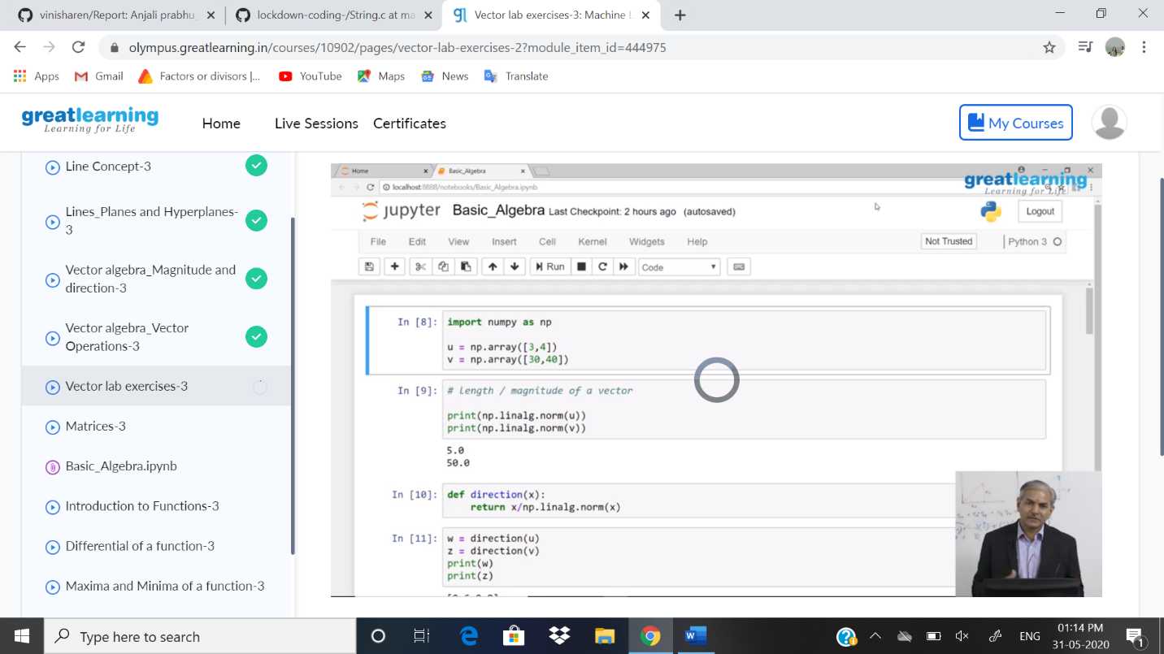

ONLINE CODING DETAILS:

PROBLEM 1:

**Write a c program to count Uppercase, Lowercase, special character**

**And numeric values for a given string**

SNAPSHOT: